**Contents**

(Streaming) on ​​Youtube 2

Broadcasting on Fecebook 6

Facebook's Facebook Guide: 9

# Broadcasting YouTube

Bookmark My Youtube Channel

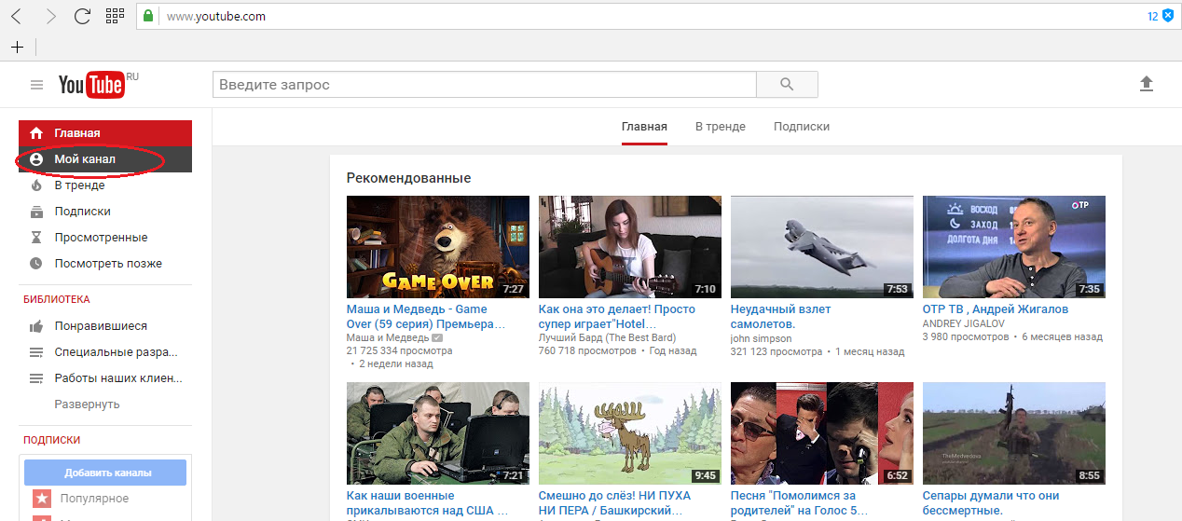

Click Add Video:

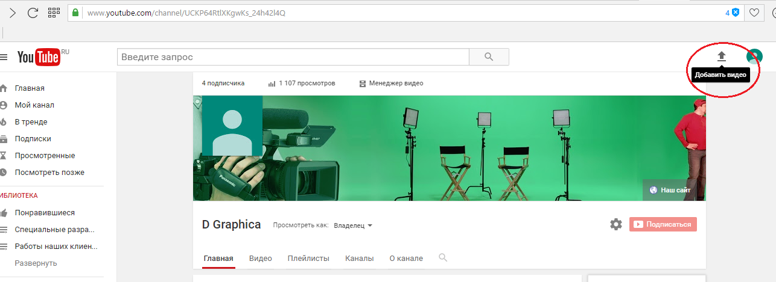

On the page that opens, on the Live Broadcast tab, click Start :

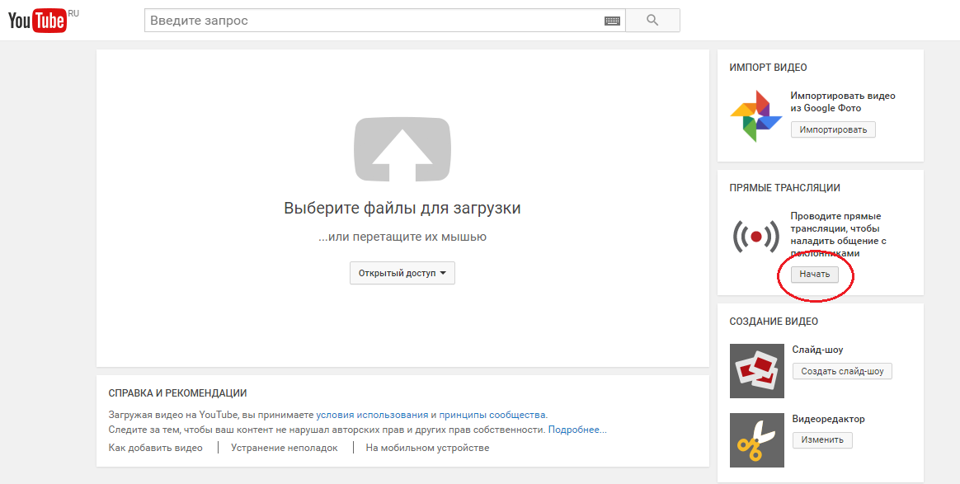

In the AllMix program, on the Tools toolbar, open the Settings tab ...  
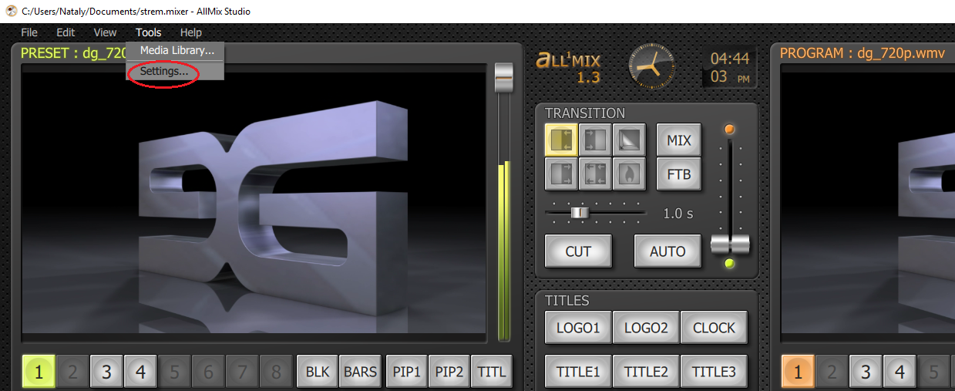

In the Streaming section, fill in the Url and Stream Name

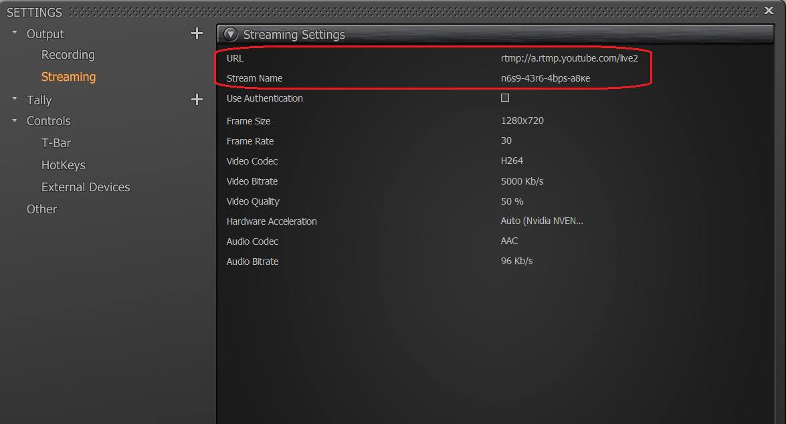

fields:

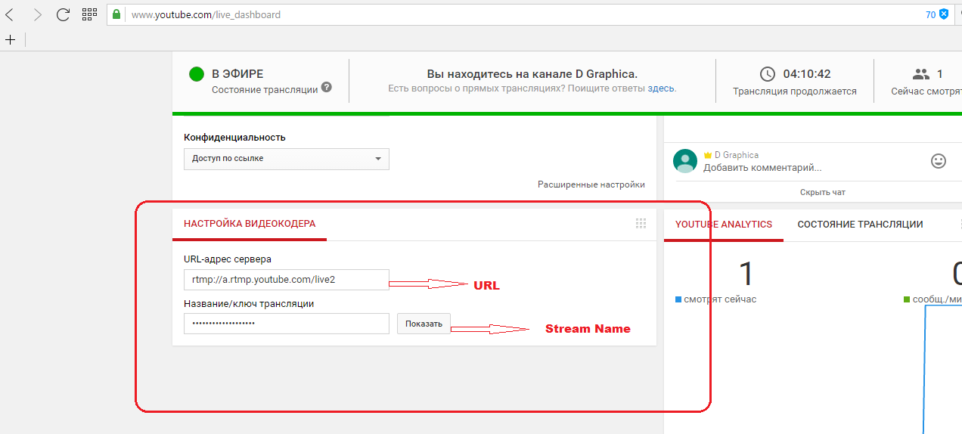

On the Program panel, launch the Streaming video:

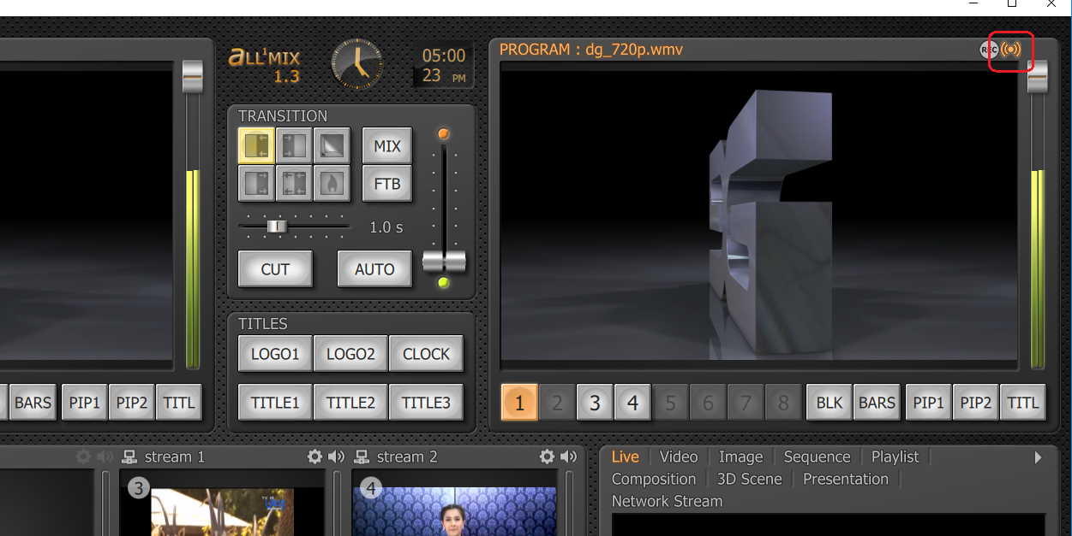

# Broadcast to Fecebook

1. Log in to page, which are going to broadcast.

2. Click the button **Live**

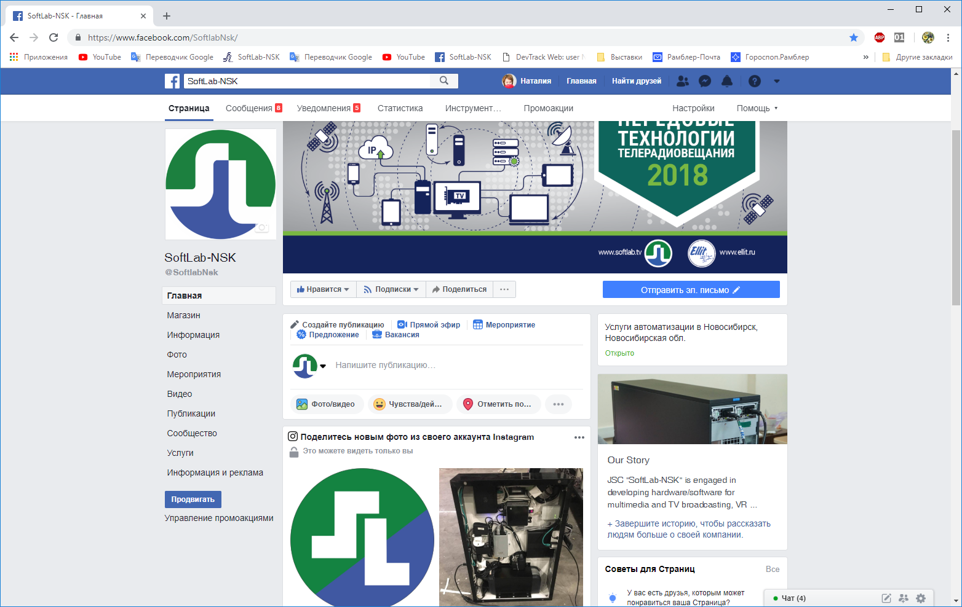

3. A window will open

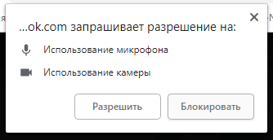

Click **Block**, since we are going to broadcast from the program. The window closes

4. Click the button **Connect**.

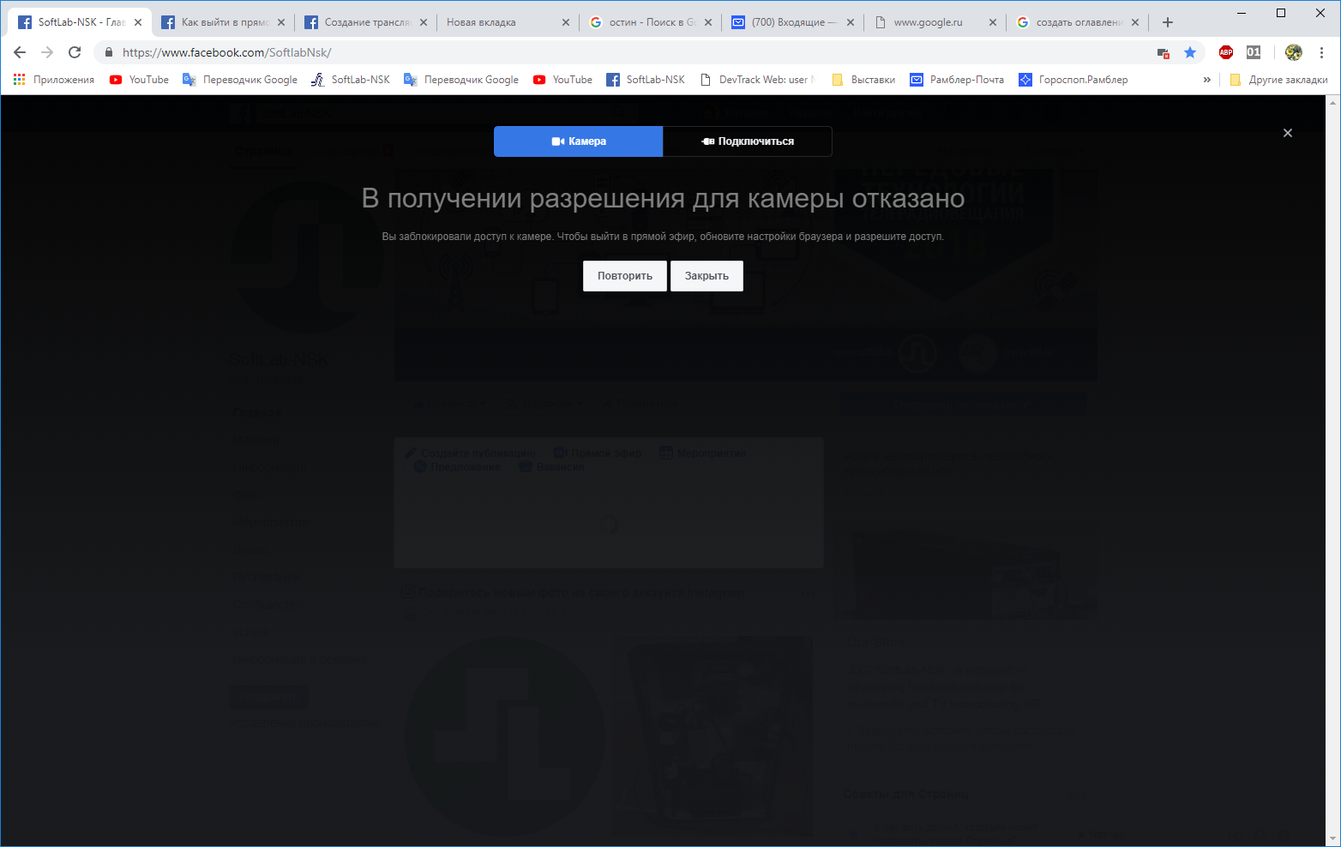

5. A window will open. The window

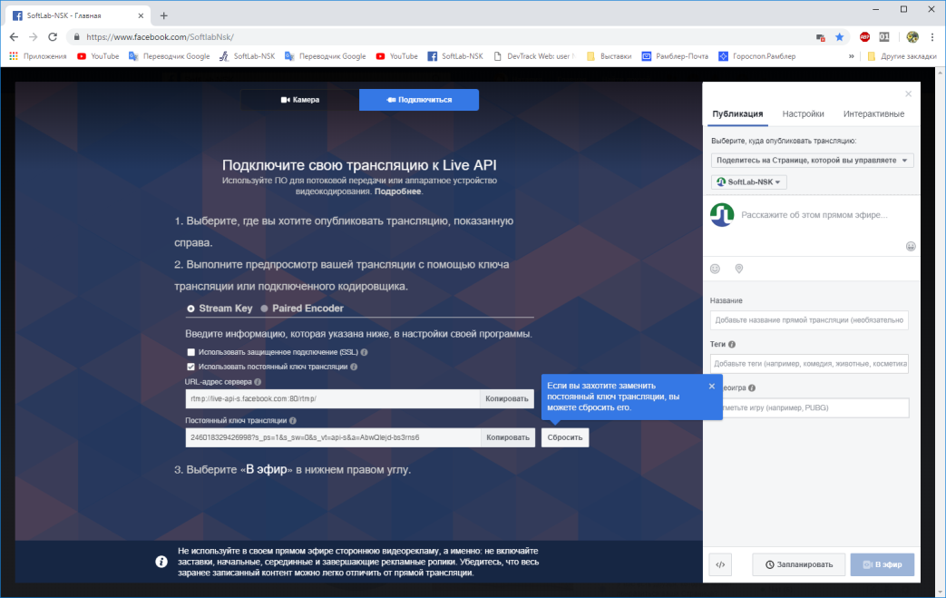

contains the URL and translation key.

6. Enter the URL and translation key in the All'Mix program. To do this, in the main window, on the toolbar, **Tools** open the tab **Settings...**  


In thesection, **Streaming** fill in the fields **Url** and **Stream Name**:



7. In the main window of the program, start the broadcast of the Broadcasting



# Guide on Facebook:

https://www.facebook.com/ help / 587160588142067