Protection (crypting) of 3D scenes

1. General information.

For programs of the AllMix family (OMix, AllCast, etc.), the option of crypting 3D scenes is provided. The ability to encrypt and use crypted scenes is specified in the AllMix license in the form of two lists of categories (the category can include both a single user and a group of users).

The first list of "Encode Categories" defines the categories for which encoding of 3D scenes is allowed.

The second list of "Decode Categories" determines which categories of crypted 3D scenes are allowed to load.

A cripted 3D scene (crypted FBX file) can not be imported into 3DS Max or into any other program. A crypted file can be loaded only in the AllMix family program and only with the registration corresponding to the category for which this FBX file is crypted.

Typically, the registration file for the seller of 3D content contains a complete list of all categories in both lists, and the end user license contains a single category in the decode list. However, depending on the licensing policy, any combination is possible. For demonstration 3D scenes, you can create a category with a name, for example, "Everybody" (or some other name) and every user licenses can consits this category. In this case, all users can download the encrypted FBX marked category "Everybody". But without the opportunity to change it.

2. Crypting * the FBX file.

Crypting is performed in the 3D scene editor.

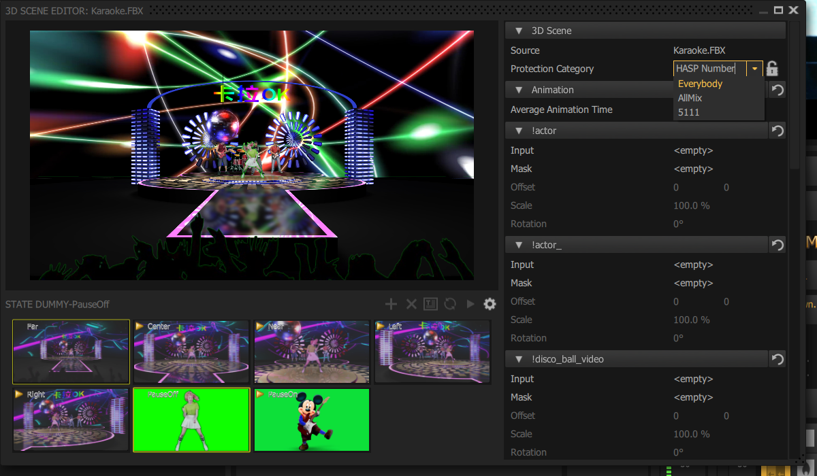

To do this, you need to load the scene and enter to the scene editor. Then select the needed encode category from the drop-down list and click on the "Open Lock" icon. Changing icon from "Open Lock" to "Locked Lock" means that the file is encrypted.

Protection Category:

- **HASP Number** - it is possible to enter the key number of a specific user;

- **Everybody** – category included in sample registration for all users;

- **AllMix** – category for AllMix user group;

- **5111** – number of client HASP key as determined by registration.

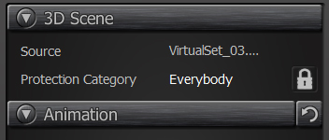

Original FBX copied to file with the extension * .FBX.bak. This file should not be sended to the end user in any case. No way to decode crypted FBX file, so crypted FBX can not be decoded, for example, for encoding to different category or to load into 3DS Max.