Титр Location 17_Location
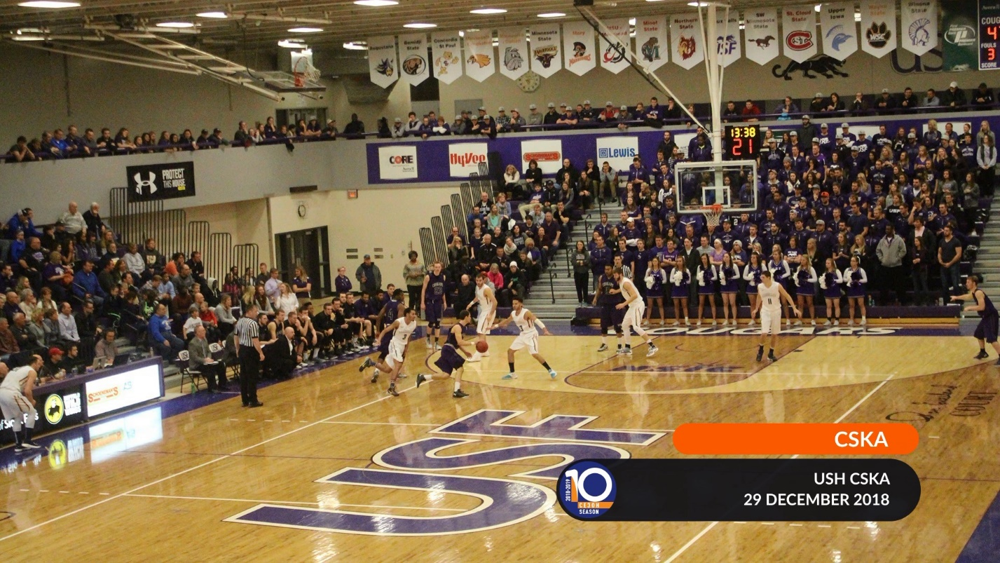
Team_1_Name - кажется название команды хозяев
Game_Place
Game_Date

Титр GeoTitle 01_MatchID
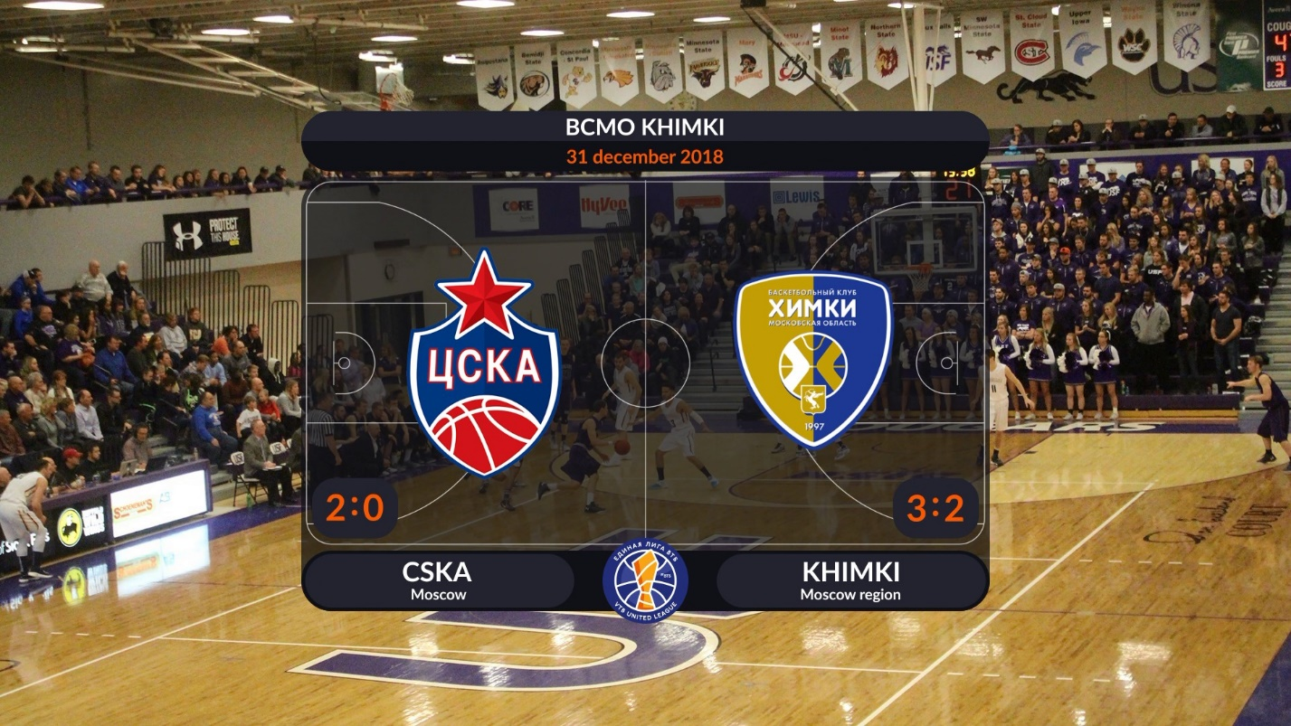

Game_Place
Game_Date
Team_1_LogoBig Team_2_LogoBig
Team_1_Num1 : Team_1_Num2 Team_2_Num1 : Team_2_Num2
Непонятные цифры
Team_1_Name Team_2_Name
Team_1_Region Team_2_Region

Титр Sostav 03_Sostav
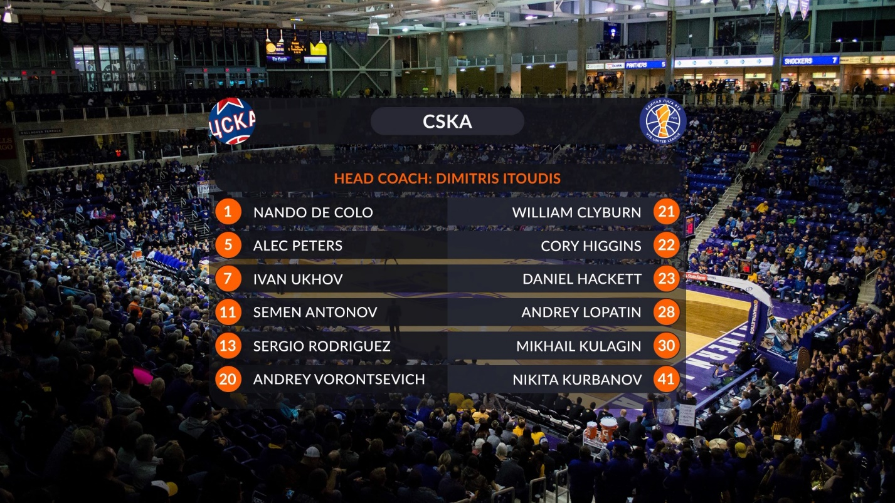
Team_N_Name Team_N_Logo
Game_SzCoach Team_N_CoachName
Team_N_Player_1_Number Team_N_Player_1_Name 1..12

Титр RefereeS 05-­‐4_Referee3
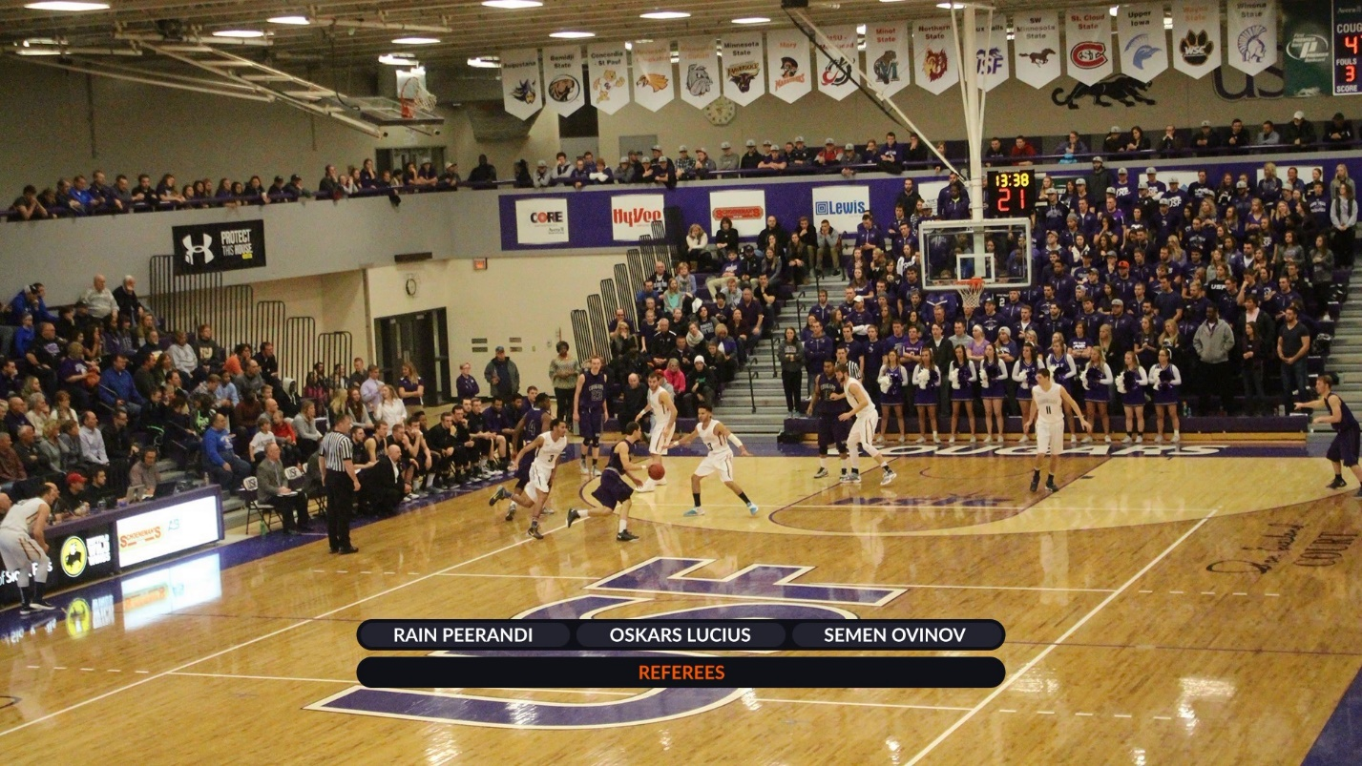
Game_Referee1Name Game_Referee2Name Game_Referee3Name
Game_SzReferees

Титр Starting 04_Start5_NO_phoho
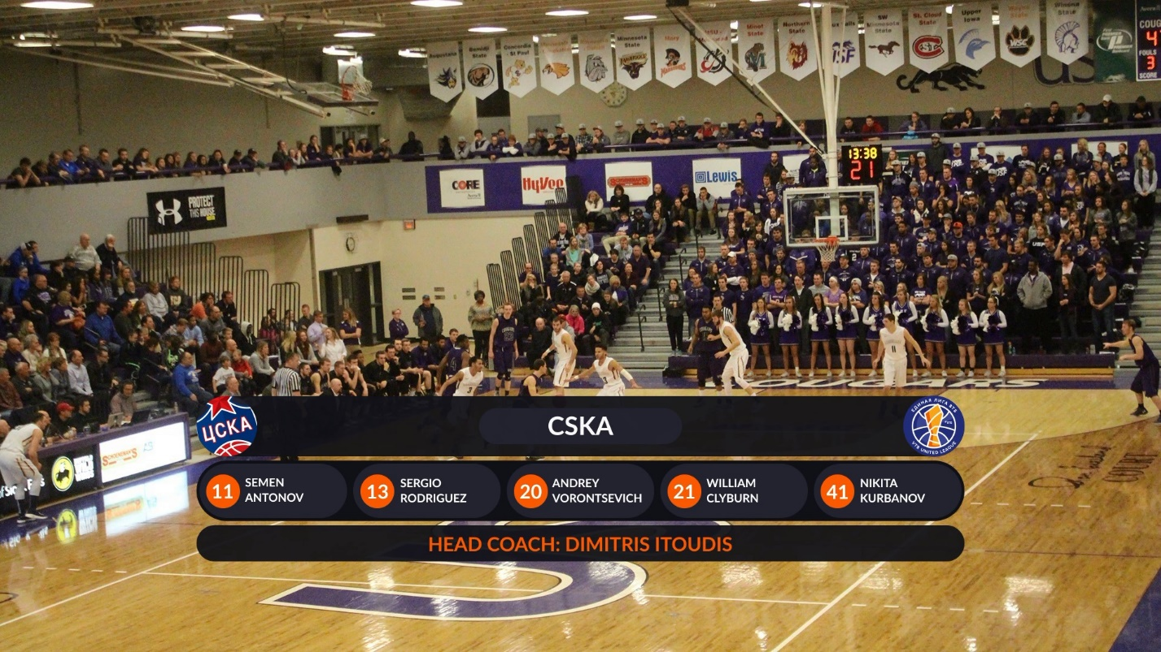
Team_N_Logo Team_N_Name
Team_N_Player_1_Number Team_N_Player_1_FirstName Team_N_Player_1_ShortName 1..5
Game_SzCoach Team_N_CoachName
Титр ScoreBig 07_Score_BIG
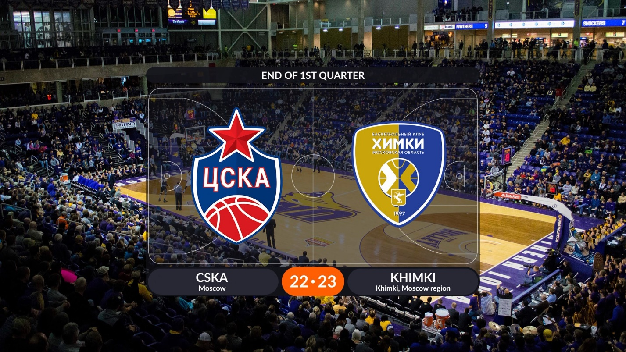
Game_PeriodName
Team_1_LogoBig Team_2_LogoBig
Team_1_Name Team_2_Name
Team_1_Region Team_2_Region
Team_1_Score Team_2_Score

Титр Coach 05-­‐2_Player_2Line
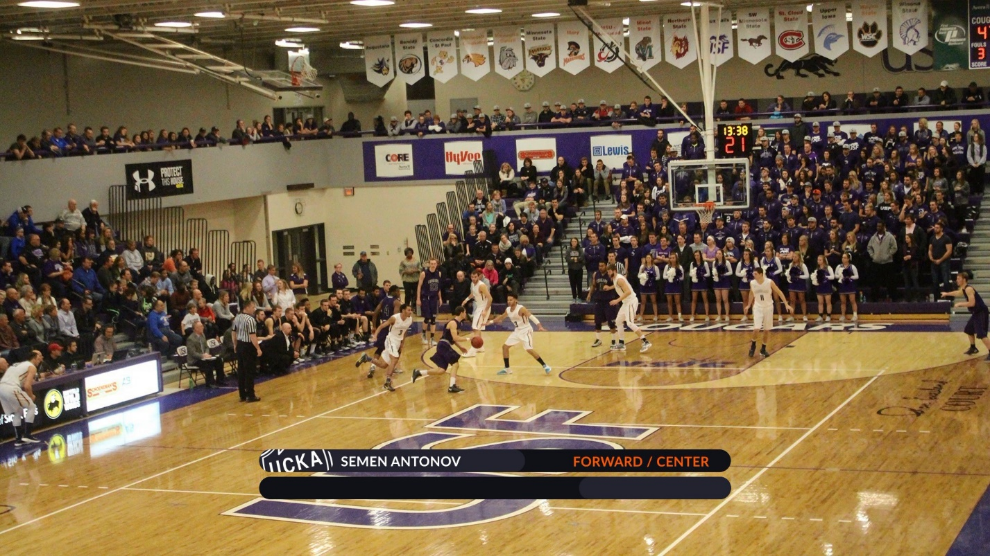
Team_N_LogoLine Team_N_CoachName Game_SzCoachRole

Титр ScoreInPeriod 08_Score_1-­‐4
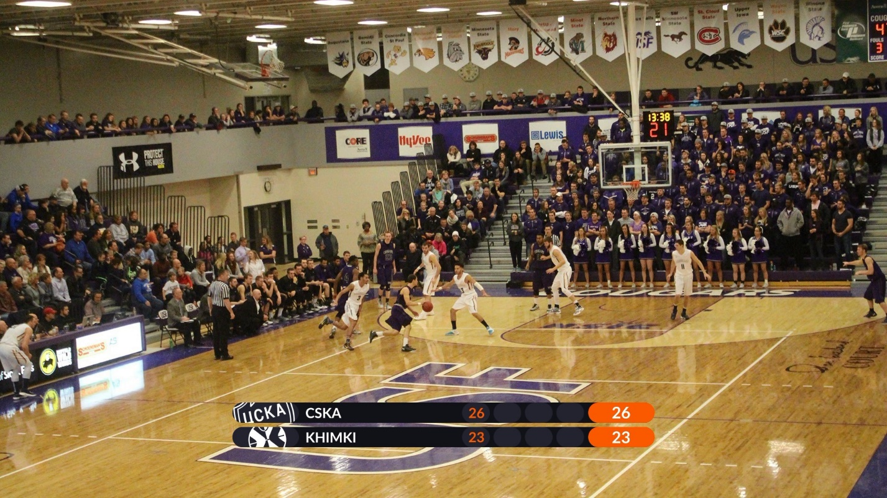

Team_1_LogoLine Team_1_Name
Team_2_LogoLine Team_2_Name
Team_1_Period_1_Score Team_1_Period_2_Score
Team_1_Period_3_Score Team_1_Period_4_Score Team_1_ Score
Team_2_Period_1_Score Team_2_Period_2_Score
Team_22_Period_3_Score Team_2_Period_4_Score Team_2_ Score

Титр UpScore 02_Score
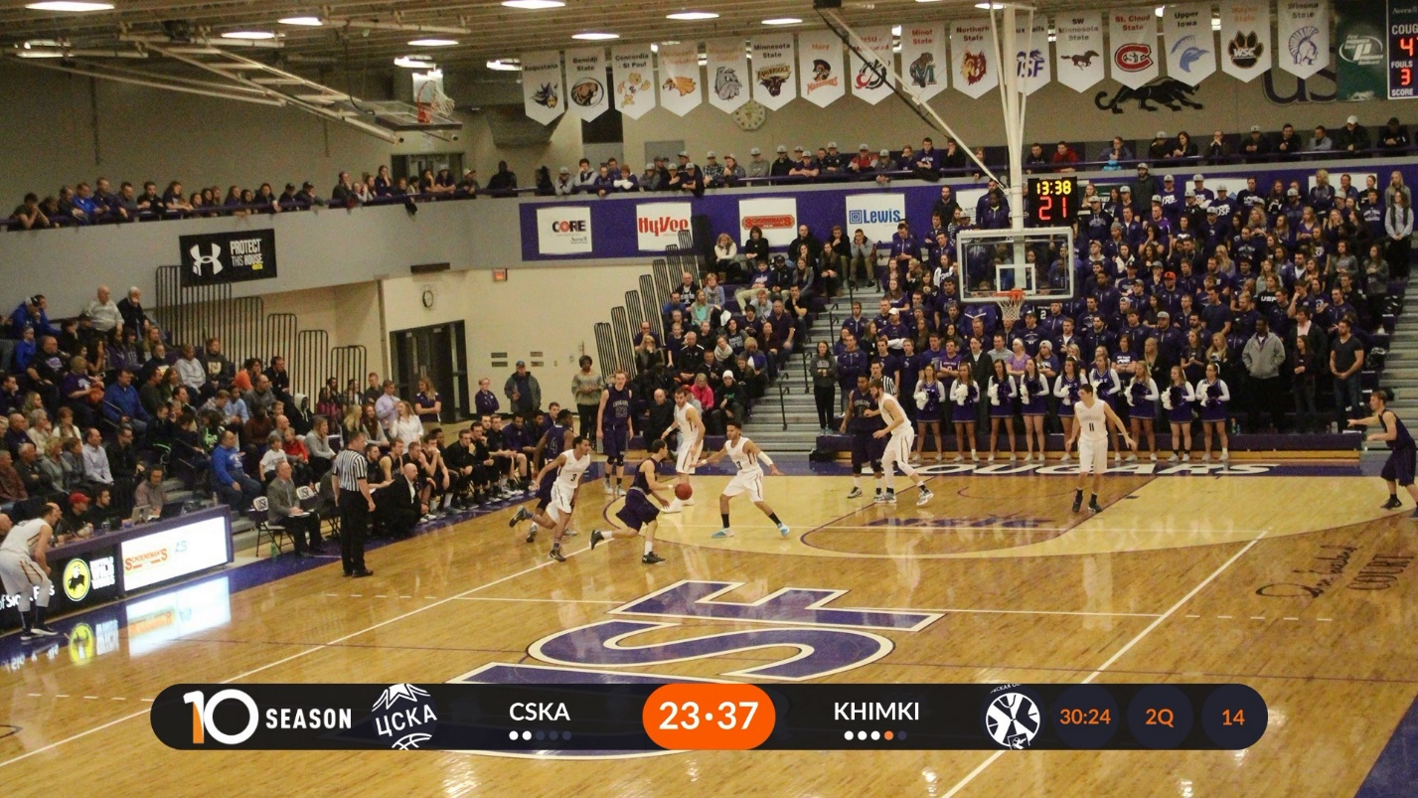
Team_1_Logo Team_1_Name Team_1_Score Team_2_Score Team_2_Name
Team_2_Logo Timer Period_Name Game_SzQuater BackTimer
Штрафные кружки реализованы в Team1Fouls0Storyboard…. Team1Fouls5Storyboard

Титр Player 05-­‐2_Player_2Line
Team_N_LogoLine Player_Name Player_Role

Титр DownScoreStart 11_protivostoyanie_komand (Local Time)
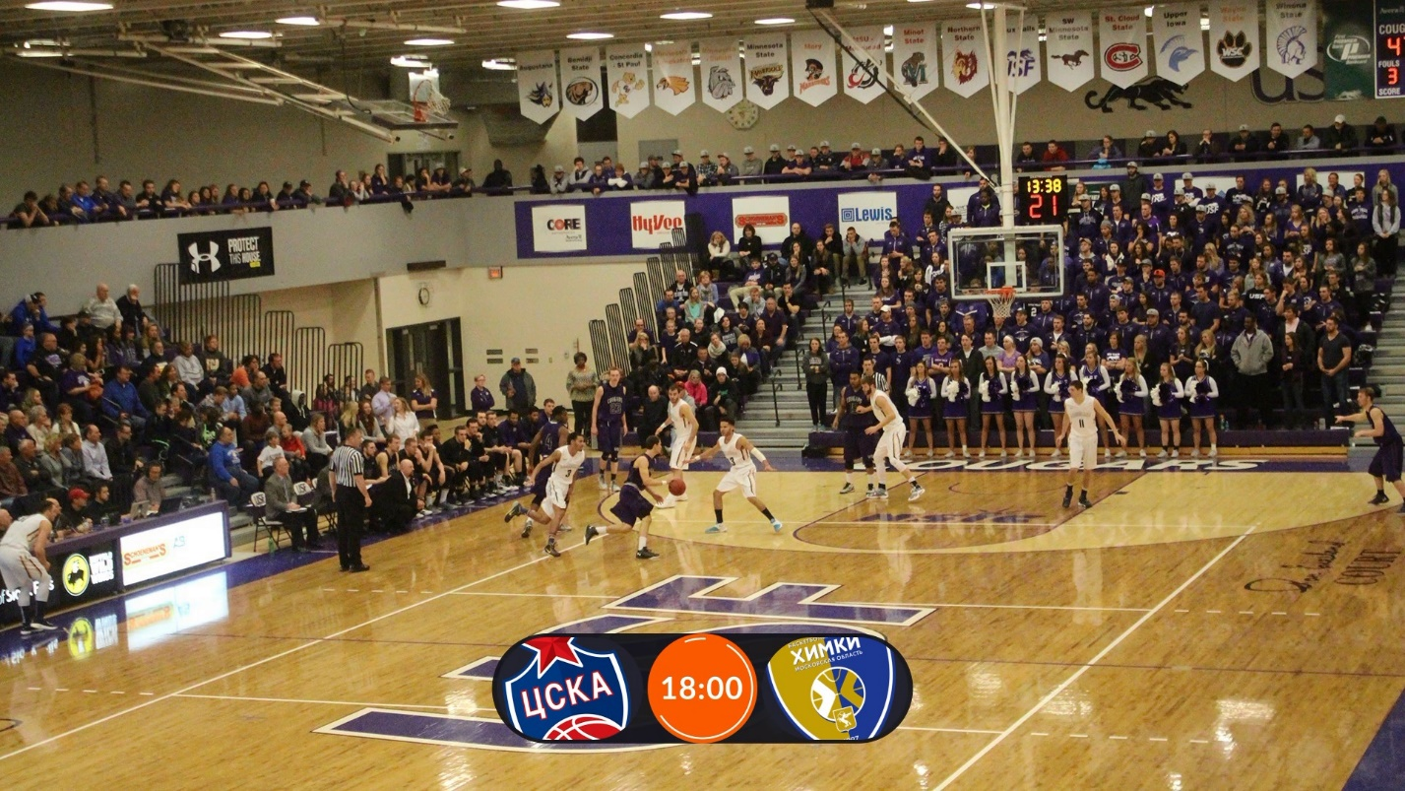
Team_1_LogoOval Game_StartTime Team_2_LogoOval

Титр DownScore 11_protivostoyanie_komand (Score)
Team_1_LogoOval Team_1_Score Team_2_Score Team_2_LogoOval

Титр StatGame 12_Statistika_st
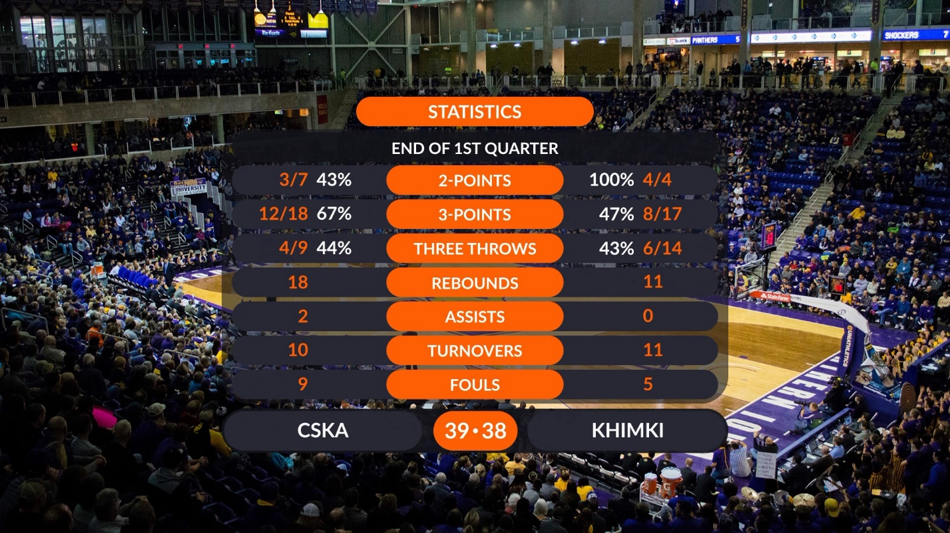
Game_SzStatistics
Game_PeriodName
Game_Sz2Points
Team_1_P2M Team_1_P2A Team_2_P2M Team_2_P2A
Game_Sz3Points
Team_1_P3M Team_1_P3A Team_2_P3M Team_2_P3A
Game_SzRebounds
Team_1_RB Team_2_RB
Game_SzAssists
Team_1_AST Team_2_AST
Game_SzTurnovers
Team_1_TOV Team_2_TOV
Game_SzFouls
Team_1_FOL Team_1_FOL
Team_1_Name Team_1_Score Team_2_Score Team_2_Name

Титр TimeOut 09_Time_out
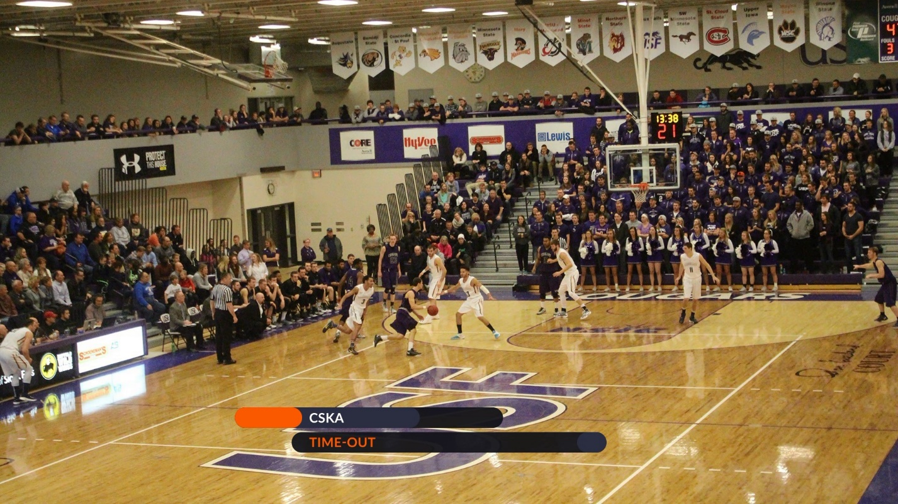
Team_N_Name
Game_SzTimeOut

Титр Name
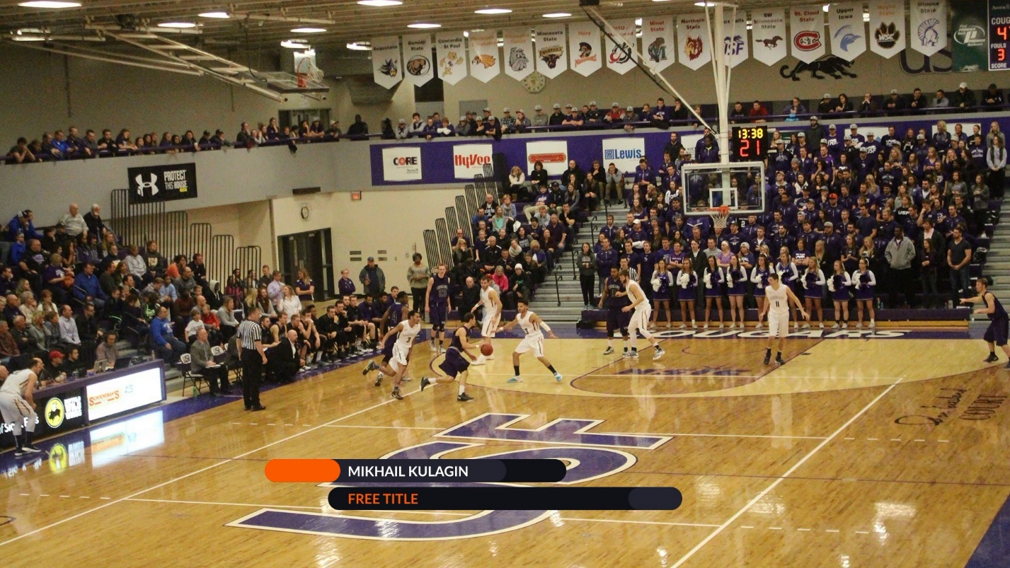
Game_PersonName
Game_PersonRole

Титр Standing 21_Standings
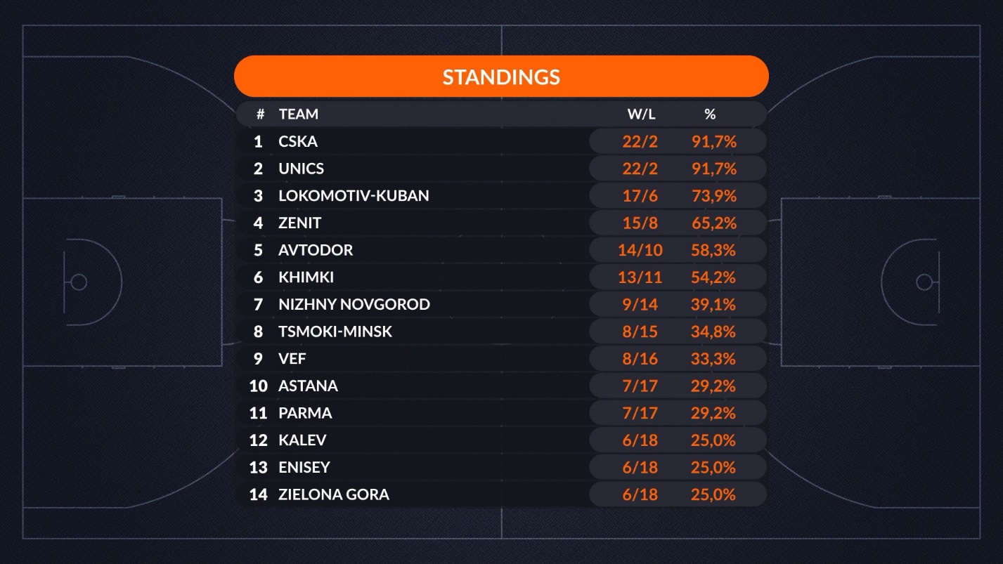
Num1..Num14
CSV_1_Name CSV_1_Win CSV_1_Loss CSV_1_Percent

Титр GameDay 22_Gameday
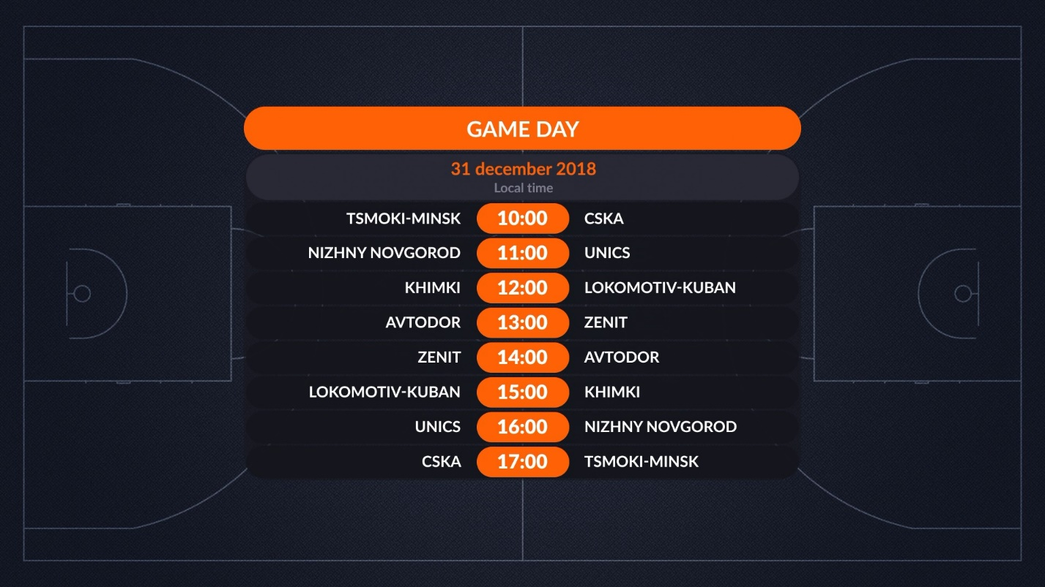

Game_Date
CSV_1_NameA CSV_1_Time CSV_1_NameB
1….8

